|  |
| --- |
| **ΥΛΙΚΟ ΧΩΡΙΣ ΑΞΙΑ**  **MATERIAL WITHOUT VALUE** |

**MINISTRY OF EDUCATION AND RELIGIOUS AFFAIRS**

**CENTRE FOR THE GREEK LANGUAGE**

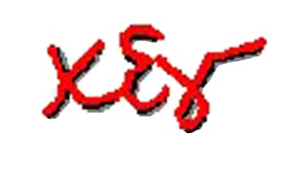

1, KARAMAOUNA ST., SKRA SQ.

551 32 KALAMARIA, THESSALONIKI,

GREECE

TEL: 0030 2313 331540, 0030 2313 331541

E-mail: ellinomatheia@komvos.edu.gr